`­­­

# REAL TIME LOCATION IDENTIFICATION AND MESSAGE TRANSMISSION ALERTING SYSTEM

Submitted in partial fulfilment of the requirements of the degree of

**BACHELORS OF ENGINNERING**

By

**Nishit Barot (5)**

**Aadi Fernandes (19)**

**Aaryaa Padhyegurjar (43)**

**Rashi Parmar (44)**

**Ramkrishna Sahu (54)**

Supervisor:

**Mr. Yogesh Pandit**



Department of Electronics/ Vivekanand Education Society’s Institute of Technology/

University of Mumbai

Year: 2020-21

# CERTIFICATE

This is to certify that the project entitled “Real Time Location Identification and Message Transmission Alerting System” is a bonafide work of Nishit Barot (5), Aadi Fernandes (19), Aarya Padhyegurjar (43), Rashi Parmar (44) and Ramkrishna Sahu (54) submitted to the University of Mumbai in a partial fulfilment of the requirement for the award of the degree of the Undergraduate in Electronics Engineering.

--------------------------------- Project Guide

Mr. Yogesh Pandit

---------------------------------- ----------------------------------

Head of Department Principal

Mrs. Kavita Tiwari Dr. (Mrs) J. M. Nair

**PROJECT REPORT APPROVAL FOR B.E.**

This project report entitled ***“Real Time Location Identification and Message Transmission Alerting System”*** byAaryaa Padhyegurjar, Rashi Parmar, Aadi Fernandes, Nishit Barot and Ramkrishna Sahu is approved for the degree of Bachelor of Electronics Engineering.

Examiners

1.---------------------------------------------

2.---------------------------------------------

Date:

Place:

# DECLARATION

I declare that this written submission represents my ideas in my own words and where others' ideas or words have been included, I have adequately cited and referenced the original sources. I also declare that I have adhered to all principles of academic honesty and integrity and have not misrepresented or fabricated or falsified any idea/data/fact/source in my submission. I understand that any violation of the above will be cause for disciplinary action by the Institute and can also evoke penal action from the sources which have thus not been properly cited or from whom proper permission has not been taken when needed.

-------------------------------- --------------------------------

Nishit Barot (5) Aadi Fernandes (19)

-------------------------------- --------------------------------

Aaryaa Padhyegurjar (43) Rashi Parmar (44)

--------------------------------

Ramkrishna Sahu (54)

Date:

# ACKNOWLEDGEMENT

We are thankful to our college Vivekanand Education Society’s Institute of Technology for considering our project and extending help at all the stages needed during our work of collecting information regarding our project.

It gives us immense pleasure to express our deep and sincere gratitude to **Mr. Yogesh Pandit** (Project Guide) for his kind help and valuable advice during the development of project synopsis and for his guidance and suggestions.

We are deeply indebted to Head of the Electronics Department, **Mrs. Kavita Tiwari** and our **Principal, Dr. J. M. Nair,** for giving us this valuable opportunity to do this project. We express our hearty thanks to them for their assistance without which it would have been difficult in finishing this project and project review successfully.

We convey our deep sense of gratitude to all the teaching and non-teaching staff for their constant encouragement, support and selfless help throughout the project work. It is our great pleasure to acknowledge the help and suggestions, which we received from the Department Electronics Engineering.

# ABSTRACT

In the fast-paced life where we often tend to forget to inform our whereabouts, it is important to know the location of the members of your family.  This factor stands true especially if the person is travelling and the mobile is physically inaccessible to use. Not being able to revert back on time may induce panic, especially if the person is travelling at night and/or in a high-risk area. Within the era of a digital revolution, the Internet of Things is being widely adopted across different verticals, with surveillance and safety is no exception to it. This becomes even more essential considering the overall rise in the rate of crimes. If any family member is in immediate danger of any intensity, they would want a quick way to inform their family members of their location for their assistance or further action.

To alleviate the problems mentioned, we have developed a reliable and easy to operate application for location sharing, messaging and emergency location trigger. We built an IoT based Location Sensing Real Time Clock which would share the real time location of every family member. The prototype that we have created uses a microcontroller with IoT technologies to formulate a comprehensive solution for the problem at hand. The central idea is to make it much more intuitive and seamless to know the location of any family member at any given duration while they have access to the internet connectivity for the GPS tracking.

The solution is twofold, one being the app which would use the Thunkable framework to provide the location of the user with pinpoint accuracy. There are multiple users that can sign up to the app and join one family circle where each other’s whereabouts can be accessed easily.

Alongside this, we also have a chat system within the app which can be used by all the members within the same family circle for general conversations. The app also incorporates the provision that triggers a message to the registered numbers with the location in case of emergencies.

The other aspect of the solution being the hardware which showcases the locations based on a few predefined entries made by the user. The LEDs are controlled by the microcontroller and are pre-set based on the most probable locations that the user regularly visits, including college, home, gym and more depending on that particular individual and family circle. Now when the member of the family reaches in the vicinity of the location that has been entered using the app, the corresponding LED would glow for the user, as each user has the LEDs for every frequently visited location.

The temperature, humidity, date and time are also displayed on the LCD using the corresponding sensors and data from the internet in order to have additional benefits within the same setup. So, this entire system would not only be able to tell the location of the family members in real time but also incorporates several other critical features to make it user friendly and drastically improve its real-world applications when it is deployed.

# INDEX

|  |  |  |  |
| --- | --- | --- | --- |
| **SR NO** | **NAME** |  | **PAGE NO.** |
| 1 | INTRODUCTION |  | 1 |
| 1.1 | INTUITION BEHIND THE PROJECT |  | 2 |
| 1.2 | STRUCTURE OF THE PROJECT |  | 2 |
| 1.3 | SALIENT FEATURES |  | 3 |
| 2 | LITERATURE REVIEW |  | 4 |
| 3 | BLOCK DIAGRAM & WORKING OF PROJECT |  | 8 |
| 3.1 | WORKING OF THE PROJECT |  | 9 |
| 3.2 | CIRUIT DIAGRAM AND EXPLANATION |  | 10 |
| 3.3 | HARDWARE/ SOFTWARE SCHEME |  | 11 |
| 3.4 | THE LOCADER APP |  | 13 |
| 3.4.1 | HOMEPAGE |  | 13 |
| 3.4.2 | ADDITION OF USER’S DETAILS |  | 15 |
| 3.4.3 | ADDITION OF THE USER’S LOCATION |  | 16 |
| 3.4.4 | LOGIN/SIGNUP FEATURE |  | 17 |
| 3.4.5 | LOGOUT FUNCTIONALITY |  | 20 |
| 3.4.6 | CHAT FEATURE |  | 22 |
| 3.4.7 | SHOW LOCATION FEATURE |  | 23 |
| 3.4.8 | EMERGENCY FEATURE |  | 24 |
| 4 | RESULTS |  | 27 |
| 5 | APPLICATIONS, ADVANTAGES AND FUTURE SCOPE |  | 32 |
| 5.1 | ADVANTAGES |  | 33 |
| 5.2 | APPLICATIONS |  | 33 |
| 5.3 | FUTURE SCOPE |  | 34 |
| 6 | CONCLUSION |  | 35 |
| 7 | REFERENCES |  | 37 |
| 8 | APPENDIX | 39 | |
| 9 | DATASHEETS | 52 | |
| 9.1 | ESP8266 (NodeMCU) | 53 | |
| 9.2 | LED MODULE | 55 | |
| 9.3 | DHT11 TEMPERATURE AND HUMIDITY SENSOR | 56 | |
| 9.4 | FC-37 RAIN SENSOR | 58 | |
| 9.5 | NOKIA 5110 LCD | 60 | |

# LIST OF FIGURES

|  |  |  |
| --- | --- | --- |
| **FIGURE**  **NO.** | **NAME** | **PAGE NO.** |
| 2.1 | System architecture of mobile application | 5 |
| 2.2 | Significant Locations of the user based on GPS data | 6 |
| 2.3 | Clusters of Locations that the user most frequently visits | 7 |
| 3.1. | Location Sensing and Message Transmission Module | 9 |
| 3.2 | Hardware Circuit Diagram and Representation | 10 |
| 3.3a | Tabular overview of the hardware specifications | 11 |
| 3.3.b | Tabular overview of the software specifications | 12 |
| 3.3.c | Flowchart of the entire system | 12 |
| 3.4 | Logo of Locader App | 13 |
| 3.4.1.a | Thunkable - Homepage of the App | 13 |
| 3.4.1.b | Homepage of the Locader App | 14 |
| 3.4.2.a | Thunkable - Adding basic details of the user to firebase | 15 |
| 3.4.2.b | Entering details in the Locader App | 15 |
| 3.4.3.a | Thunkable - Adding locations of the user to firebase | 16 |
| 3.4.3.b | Adding locations in the Locader App | 17 |
| 3.4.4.a | Thunkable - Signup Feature for the user | 17 |
| 3.4.4.b | Thunkable – The Login Functionality | 18 |
| 3.4.4.c | Thunkable - Signup Prepopulating Function | 19 |
| 3.4.4.d | The Login Feature with the prepopulating function on the Locader App | 19 |
| 3.4.5.a | Thunkable - User logging out of the app | 20 |
| 3.4.5.b | Logout Screen on Locader App | 21 |
| 3.4.6.a | Thunkable - Chat Feature of the family members | 22 |
| 3.4.6.b | Chat Feature on the Locader App | 22 |
| 3.4.7.a | Thunkable - Viewing Current Locations of the Users | 23 |
| 3.4.7.b | Viewing the location of the users using Locader App | 24 |
| 3.4.8.a | Thunkable - Emergency Feature | 24 |
| 3.4.8.b | Emergency Feature on Locader App | 25 |
| 3.4.8.c | Location sent after the emergency button is triggered | 26 |
| 4.1 | Circuit when all users are at home and the rain sensor is deactivated | 28 |
| 4.2 | Circuit when all users are at home and the rain sensor is activated | 28 |
| 4.3 | All users are at home | 29 |
| 4.4 | All except one of the users (aashree2019) is not at home | 29 |
| 4.5 | Firebase: All the users are at home | 30 |
| 4.6 | Firebase: All except one of the users (aashree2019) is not at home | 31 |
| 9.1 | ESP8266 (NodeMCU) | 53 |
| 9.2 | LED Module | 55 |
| 9.3 | DHT11 Temperature & Humidity Sensor | 56 |
| 9.4 | FC-37 Rain Sensor | 58 |
| 9.5 | Nokia 5110 LCD | 60 |

**CHAPTER 1**

**INTRODUCTION**

**CHAPTER 1 – INTRODUCTION**

**1.1 INTUITION BEHIND THE PROJECT:**

The intuition behind this project was safety and security of our loved ones. Many a times, we forget to tell our family members about where we are which can cause a lot of confusion and panic at home. The situation would remain the same until a call back or message is received. However, if we know exactly where the person is, it can give them some sense of security – as they know that the person is on their way via their usual route but the phone is not currently accessible to them. Moreover, if there is any kind of emergency that they are in – the inbuilt emergency feature can be used in order to trigger a message to all the emergency contacts about their exact location, after which further action can be taken based on the entire situation. This entire system is based upon knowing the location of the family members at a glance. Moreover, another important factor is that the person need not be technologically sound in order to know the approximate location either – as we have the hardware system which would prompt the whereabouts using the LEDs. This project and can be scaled up very easily in order to be able to incorporate multiple users and families by entering their respective locations and signing in to their family tree via the signup option in the app. This is a safe, secure and reliable way to ensure the safety and well being of the family members which was the driving force behind creating this project

**1.2 STRUCTURE OF THE PROJECT:**

The structure of the project is divided into two realms – the hardware functionalities and the software app. The hardware includes the usage of two sensors: temperature & humidity sensor and rain sensor – which displays the information on the LCD screen. This information is important as the user would know about the climatic conditions at their locality. The most vital factor however is the microcontroller which would again be relayed with these two sensors and also with LEDs and finally the LCD. The microcontroller would pass on the information of the user through the program that has been fed into it, alongside the current time and other sensor information. The LEDs are placed based on the name and most visited locations of the user and will be triggered once that user reaches the particular location or it’s vicinity.

The software aspect of it is basically an app that would be able to perform multiple functionalities. The location of the family members can be known at any given point of time and we also have a chat feature incorporated so that the users can seamlessly chat and get to know about each other’s whereabouts. Moreover, it has the super critical emergency button feature in it which triggers the location of the user being sent to the rest of the family members in case of any kind of emergency. The hardware and software work in absolute synchrony to provide us with a full-fledged solution for the problem at hand.

**1.3 SALIENT FEATURES:**

The entire project has a lot of very striking features that cement its functionalities in the real-world:  
1. Safety and security of members of the family via GPS based location tracking

2. App is secure because of the implementation of the login and signup features which provides an added layer of security to prevent unauthorized access

3. It has both – hardware and software that can be used to track the locations

4. Real-time updating is done which makes all the data accurate

5. Appreciably fast chat response time

6. Excellent user experience with videos and other clips incorporated into the app

7. Little to no delay in updating of the hardware LED lights once the location of the GPS changes and is reflected in the app

8. Very low power and monetary requirements with basic electronic devices

9. Gives loads of additional information such as time and climate updates

10. Easy to scale up with minimal changes to the code and hardware structure

# CHAPTER 2

**LITERATURE REVIEW**

**CHAPTER 2 – LITERATURE REVIEW**

**[1] Paper Title: Mobile Emergency Response Application Using Geolocation for Command Centers**

**Authors: Jethro B. de Guzman, Ritz Carlo C. de Guzman, and Engr. Remedios G. Ado**

The paper includes a system that would provide a reliable and more efficient medium to dispatch emergency services using a mobile application would detect user’s current location and other critical information through geolocation and send to the web application deployed in a command center.

The mobile app would be created using PhoneGap instead of a native android language in order to improvise the UI and make it seamless to adopt across several different mobile platforms. It is a free and open-source framework which uses web APIs for different mobile platforms and has the tools to integrate it with the app.

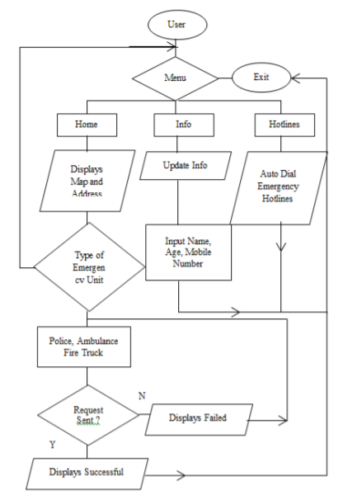

**Fig 2.1: System architecture of mobile application**

The equivalent latitude and longitude on a Google maps are retrieved using the API and GPS in order to pinpoint the exact location of the user if they have a stable internet connectivity. Our idea of utilizing the thunkable framework and GPS for the precise location of the user and a friendly user interface was derived from this.

**[2] Paper Title: Extracting Places and Activities from GPS Traces Using Hierarchical Conditional Random Fields**

**Authors: Liao L, Fox D, Kautz H**

This paper describes how to extract a person’s activities and significant places from traces of GPS data. The system uses hierarchically structured conditional random fields to generate a consistent model of a person’s activities and places. In contrast to existing techniques, this approach takes the high-level context into account in order to detect the significant places of a person. Furthermore, they indicate that the proposed system is able to robustly estimate a person’s activities using a model that is trained from data collected by other people and can be utilized in several instances including surveillance and assistive technology for the disabled. These locations are then incorporated into a Markov model that can be consulted for use with a variety of applications in order to obtain above 90% accuracy in detecting and labelling significant places.

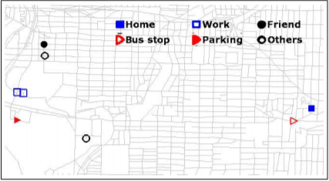

**Fig 2.2: Significant Locations of the user based on GPS data**

Our idea of the significant locations where the person usually visits has been derived from this paper. Although we would be manually entering the locations based on the locations we visit, in the further scope of this project, we could use this model and the GPS data collected in order to facilitate easier identification, labelling and improve automation of the application.

**[3] Paper Title: Using GPS to Learn Signiﬁcant Locations and Predict Movement Across Multiple Users**

**Authors: Daniel Ashbrook and Thad Starner**

Wearable computers have the potential to act as intelligent agents in everyday life and assist the user in a variety of tasks, using data to determine how users would act. Location is the most common form of data used by these applications to determine the user’s actions.  This paper presents a system that automatically clusters GPS data taken over an extended period of time into significant places. It is used in both single–user and multi-user scenarios in order to promote collaboration and cooperation between these individuals. It utilizes a variant of the k-means clustering algorithm in order to collect meaningful locations and then utilizes the Markov model to and can potentially be used in the location context for creation of a predictive model of the user’s future movements in all intelligent wearable devices.

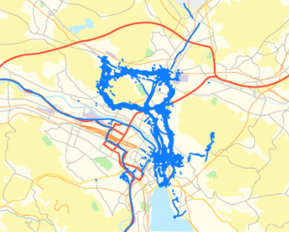

**Fig 2.3: Clusters of Locations that the user most frequently visits**

The intuition of using an area under a particular radius of the location was derived from this paper. Moreover, in further development we could use this not only to identify the significant locations but also to be able to predict the movements of the user, especially if there are any network connectivity issues and we cannot track them in real time.

# CHAPTER 3

**BLOCK DIAGRAM AND WORKING**

**CHAPTER 3 - BLOCK DIAGRAM AND HARDWARE CIRUIT**

**3.1 BLOCK DIAGRAM AND WORKING:**

Breaking down the block diagram into two segments – first we have the location sensing feature that would use the GPS on our phones in order to be able to track our exact location whenever deemed necessary. The locations that obtained using the google maps API and are very accurate, with the redeemed data being stored in the google firebase database. The GPS tracker app has several layers of operations that are performed and it is built using the thunkable framework which makes it much more intuitive to program. All of the functionalities would be explained further in detail with examples. The major takeaway is that the data that is found on firebase is entered by the user – including the basic details and the locations. The data on firebase can then be accessed by the ESP8266 in order to complete the rest of the operations. The location data is then relayed to the array of LEDs. Basically, there is an LED corresponding to every location that every user is most likely to be at and the moment they are at the location, the ESP8266 triggers and makes the LEDs glow.

The second segment is basically the emergency feature that is built into the app itself. Now that feature basically would be triggered once the button is pressed in the app. It accesses the database in order to retrieve the user’s details and also the details of the family members. Once that is done, it uses the GPS to retrieve the current location of the user which is then sent to all the members in the family circle.

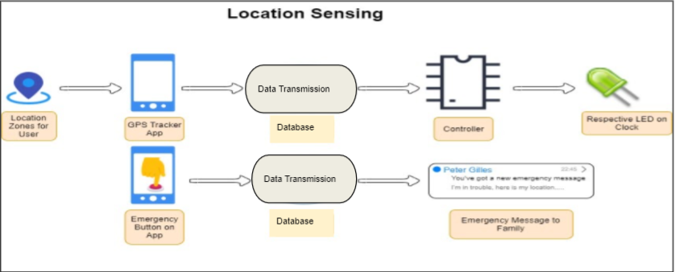

**3.1: Location Sensing and Message Transmission Module**

**3.2 CIRUIT DIAGRAM AND EXPLANATION**

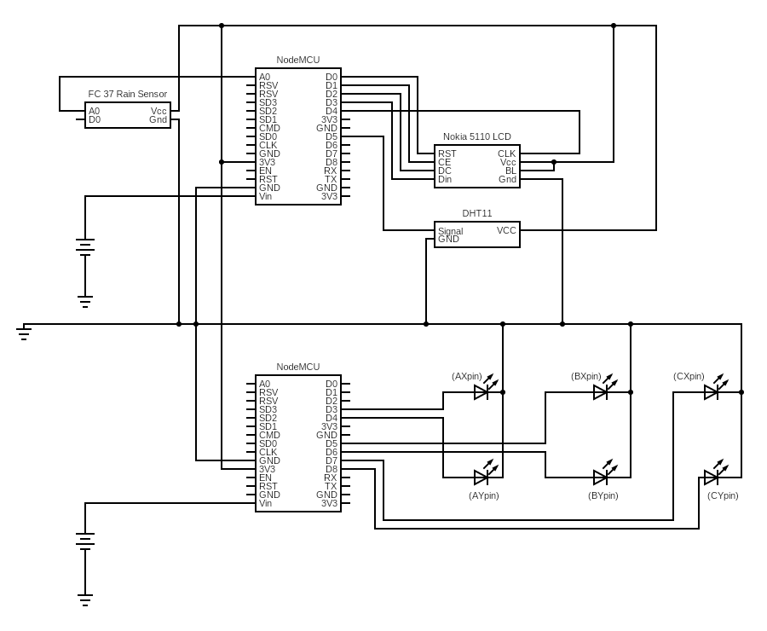

**3.2: Hardware Circuit Diagram and Representation**

The figure 3.2 showcases the hardware circuit diagram and connections of the system. Focusing on the top portion of the system first, it consists of a NodeMCU that is connected to the FC 37 Rain sensor which detects whether it is raining or not. It is also connected to the DHT 11 Temperature and humidity sensor which again, provides back the details of the surrounding temperature in terms of degree Celsius and humidity in terms of percentage. Now, all this information, alongside the real time that is accessed from the internet, is displayed to the connected Nokia 5110 LCD. Now, the bottom portion of the system consists of another Node MCU which is essentially connected to the array of LEDs. Each LED has it’s significance in terms of the user and the location that the user might be at. The NodeMCU would collect the data from firebase and light up the respective connected LEDs based on the user and the location of the user. The two segments are then relayed together in order to work an entire system which would be driven by the app.

**3.3 HARDWARE / SOFTWARE SCHEME:**

|  |  |  |
| --- | --- | --- |
| **Sr No.** | **Hardware Component** | **Description** |
| 1 | NodeMCU (ESP8266) | Microcontroller with Wi-Fi Module used for transfer of data between database and hardware |
| 2 | LEDs | To be associated with users and registered places |
| 3 | Nokia 5110 LCD Display | Used to display the real-time clock and weather status |
| 4 | DHT11 Temperature Sensor | Used to detect temperature and humidity |
| 5 | FC - 37 Rain Sensor | Used to detect the presence of rain |

**3.3.a: Tabular overview of the hardware specifications**

|  |  |  |
| --- | --- | --- |
| Sr No. | Software Required | Description |
| 1 | Firebase Database | To store the data of the users along with the specific locations |
| 2 | Thunkable X | Online interface used to design, develop and publish Android and iOS Applications |

**3.3.b: Tabular overview of the software specifications**

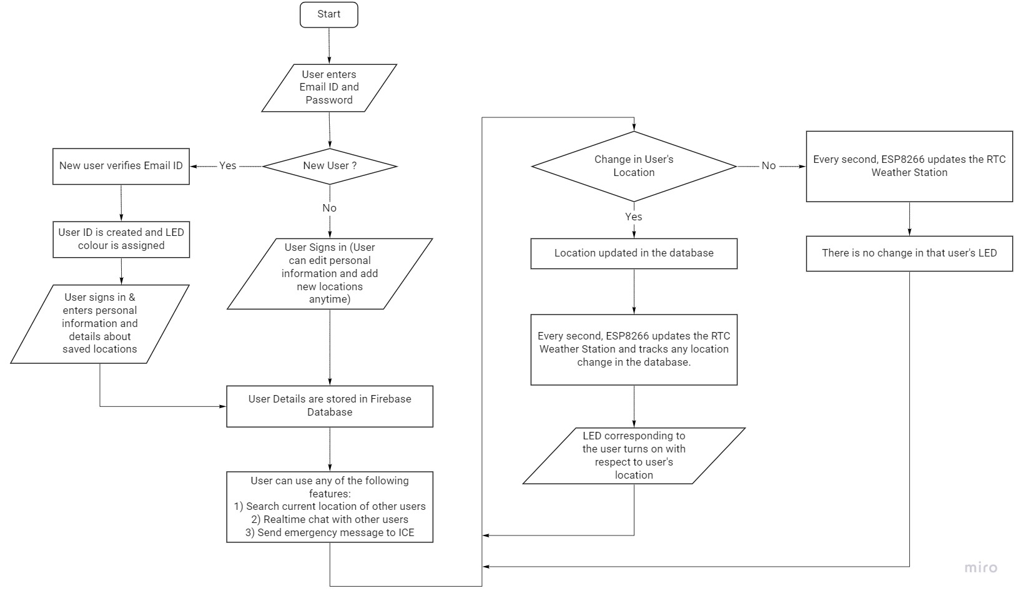

**3.3.c: Flowchart of the entire system**

**3.4 THE LOCADER APP:**

We delve deeper into the software app that we have created using the thunkable framework. The name of the app is Locader which is the alias for “Location Detection and Emergency Response”. The app has a lot of features incorporated into it – each one of them super critical for the working of this system and they will be explained in the subsequent sections.



**3.3 Logo of the Locader App**

**3.4.1 HOMEPAGE:**

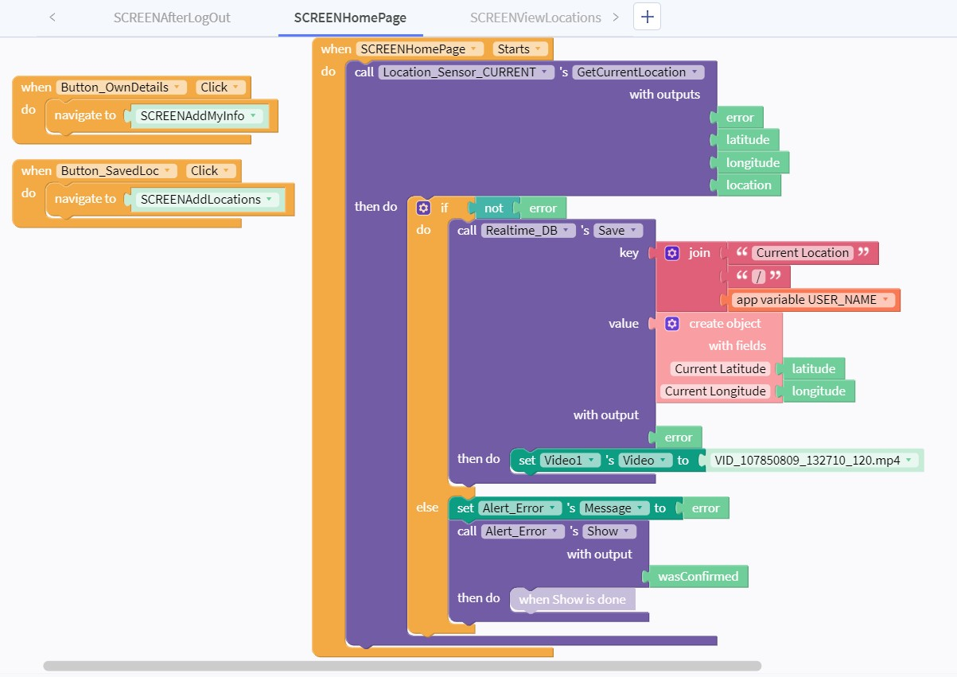

**3.4.1.a: Thunkable - Homepage of the App**

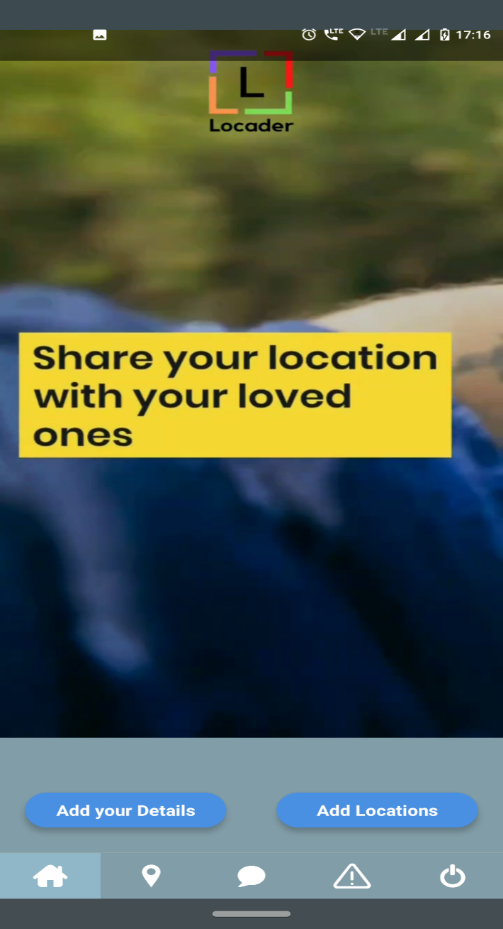

**3.4.1.b: Homepage of the Locader App**

The homepage is the page you see as soon as you open the app. Before that, we have a flash screen which would pop out before the screen loads. Once it does, we have programmed it to showcase a live video which describes the functionality and purpose of our app, Locader. We can jump from this section to the location, chat or emergency response, logout sections from the buttons showcased at the feet of the app. Above that, we have two options to select from, both of which take us to different blocks for the purpose of either adding the details or adding the locations – both of which we will learn more about in the coming sections.

**3.4.2 ADDITION OF USER’S DETAILS:**

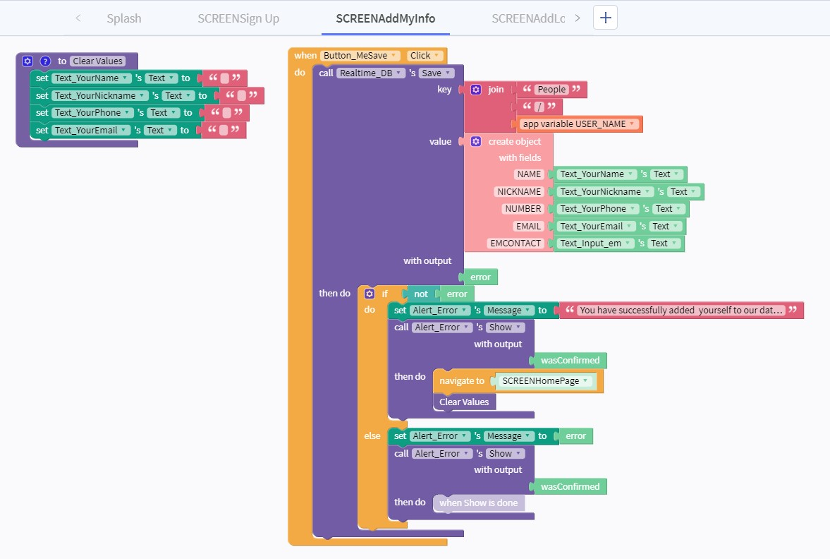

**3.4.2.a: Thunkable - Adding basic details of the user to firebase**

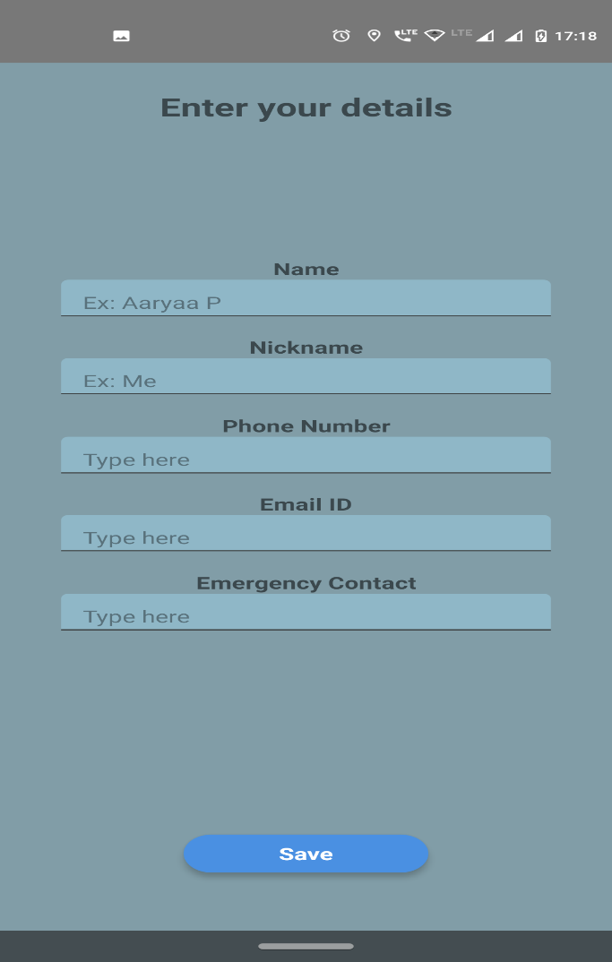

**3.4.2.b: Entering details in the Locader App**

If we select the “Add your details” option on the home page, it redirects us to this block. The functionality of the block is to basically redirect and store the basic details of the users into the firebase database. It consists of the details of the member such as their name, the nickname that will appear in the chat section, phone number which will be used to track them, email ID for verification purposes and the emergency contact to whom the message will be triggered once the emergency feature is activated. It can be retrieved later by the microcontroller for further applications.

**3.4.3 ADDITION OF THE USER’S LOCATION:**

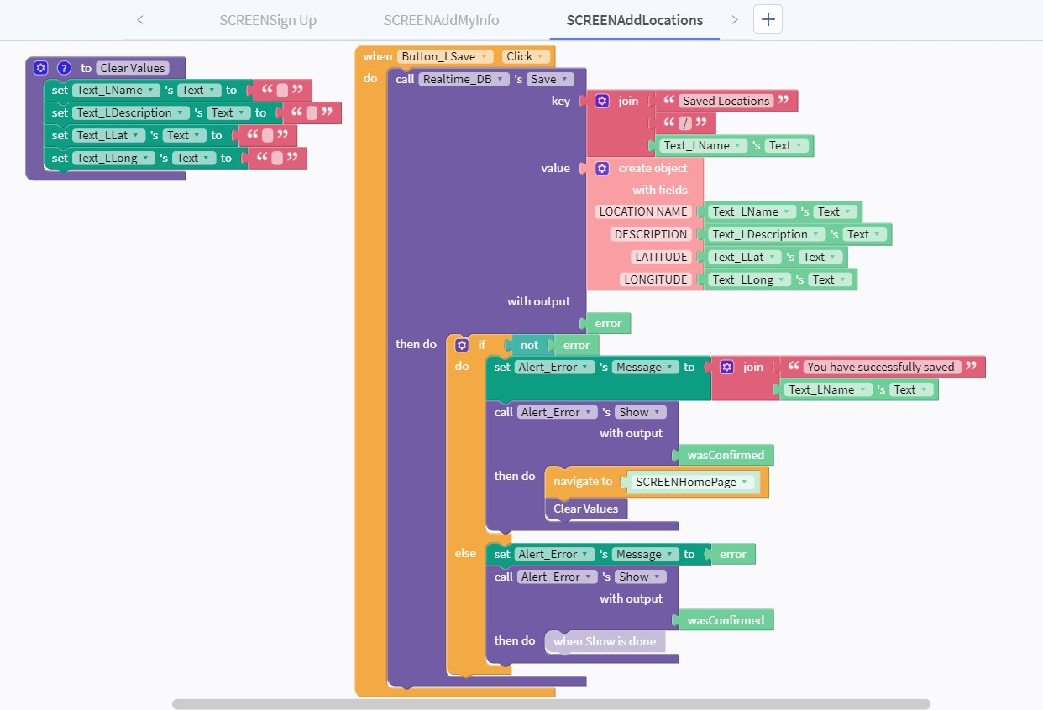

**3.4.3.a: Thunkable - Adding locations of the user to firebase**

Meanwhile, if we select “Add location” on the home screen, we would come across the feature where we need to enter the most likely location the user would be in. The co-ordinates need to be pulled up using maps and then copy pasted into the latitude and longitude sections of the app. The location name and description could also be entered and all the data is stored onto the firebase database. This would be accessed by the app to showcase the location and to use the emergency feature and also by the microcontroller during the lighting of the LEDs

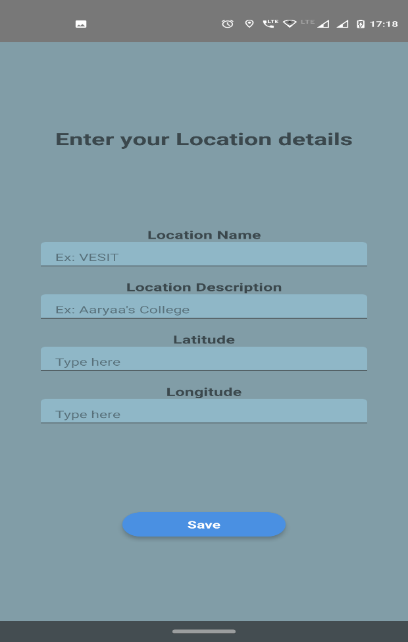

**3.4.3.b: Adding locations in the Locader App**

**3.4.4 LOGIN/SIGNUP FEATURE:**

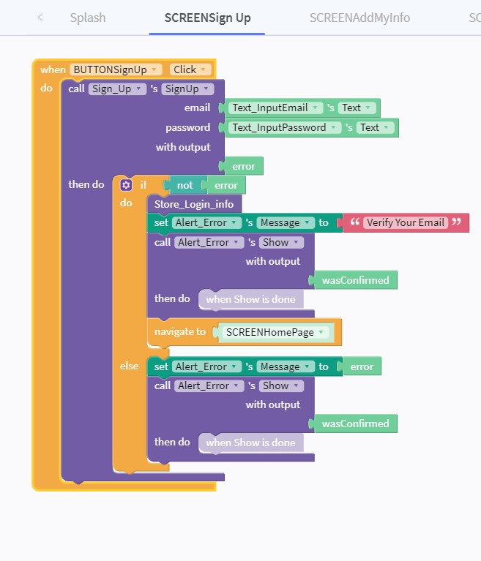

**3.4.4.a: Thunkable - Signup Feature for the user**

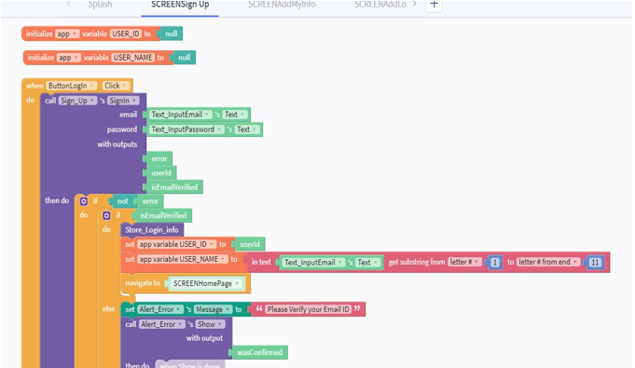

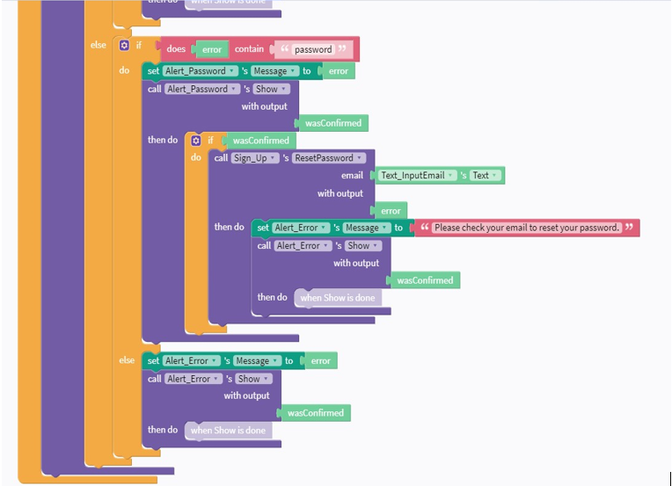

**3.4.4.b: Thunkable – The Login Functionality**

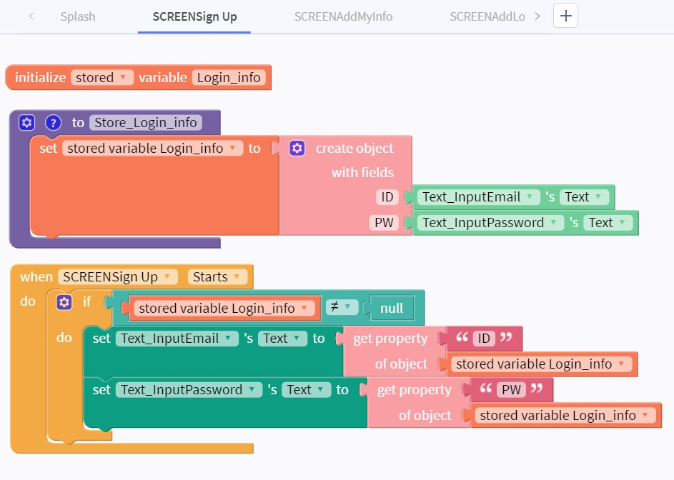

**3.4.4.c: Thunkable - Signup Prepopulating Function**

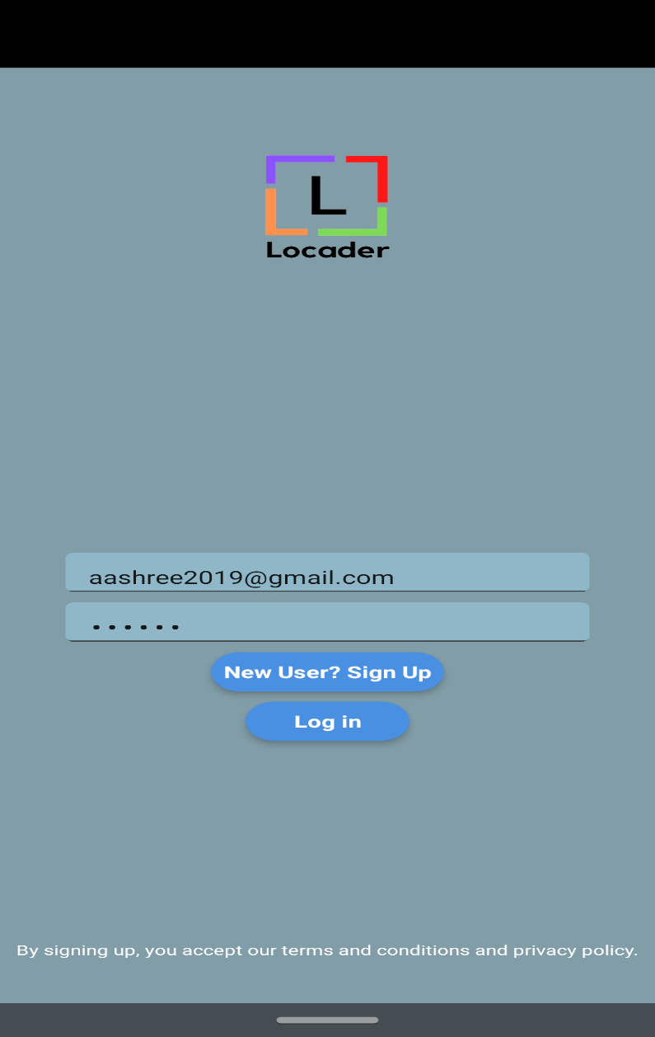

**3.4.4.d: The Login Feature with the prepopulating function on the Locader App**

Coming up to the login and signup functionality of the app, we have a quite a few features embedded within it. Firstly, the main signup feature through which the user needs to logon for the first time and setup their account. During that, there is a verification mail that is sent to the email that is registered. Following the activation, we move on to the next step of logging into the account and using the app. Now, another added functionality is the signup prepopulating function which essentially acts as an auto filler and saves the details so the user need not type it everytime they log onto the app. This saves the time and effort of the users. The signup/login page is as shown in Fig 3.3.4.d and showcases the options to either login to the app or signup as a new user.

**3.4.5 LOGOUT FUNCTIONALITY:**

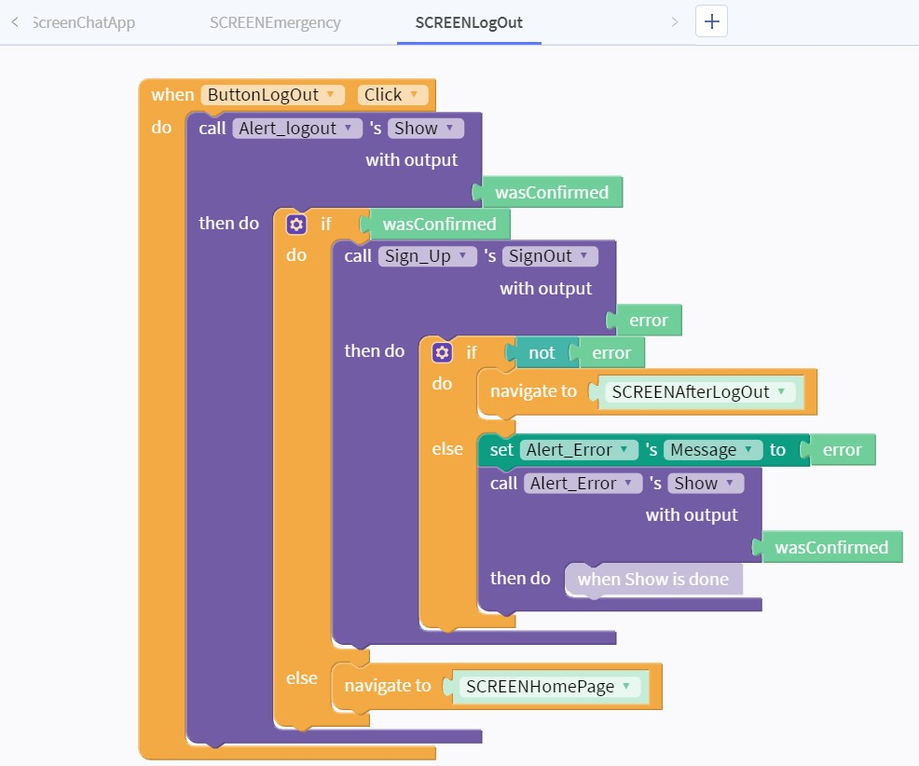

**3.4.5.a: Thunkable - User logging out of the app**

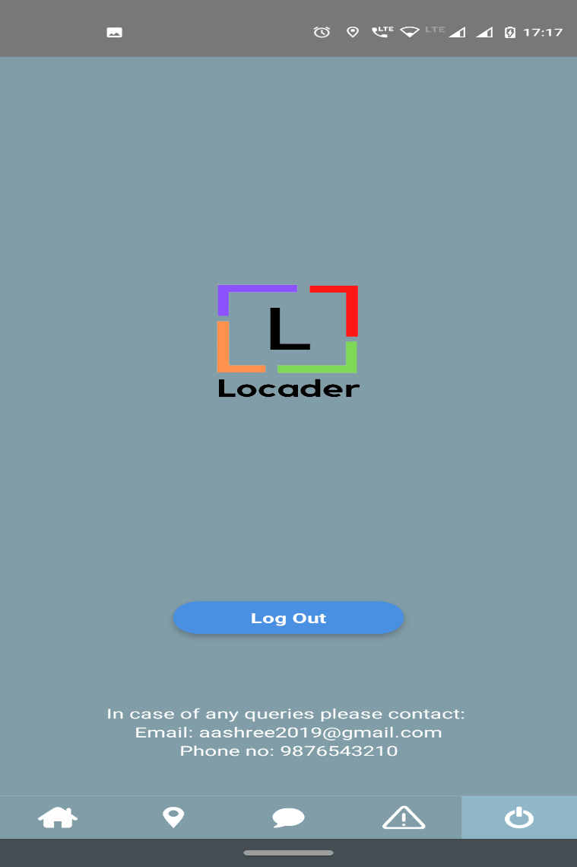

**3.4.5.b: Logout Screen on Locader App**

Now that we have logged onto the app, we might also need to change the user at some point of time, or just logout for some other reason. In that case, this is the screen where you could logout and then login whenever deemed necessary. Once you logout of the app, you will not receive messages or be able to track locations of your family members as the user is no authenticated. This acts as a layer of security to avoid anyone else from accessing the locations of any of the users without permission. This would be much more critical when the app is scaled up to have several families and many other users. In the beta version of the app, we would also add the queries section in order to receive feedback about the functions and improvements that could be made.

**3.4.6 CHAT FEATURE:**

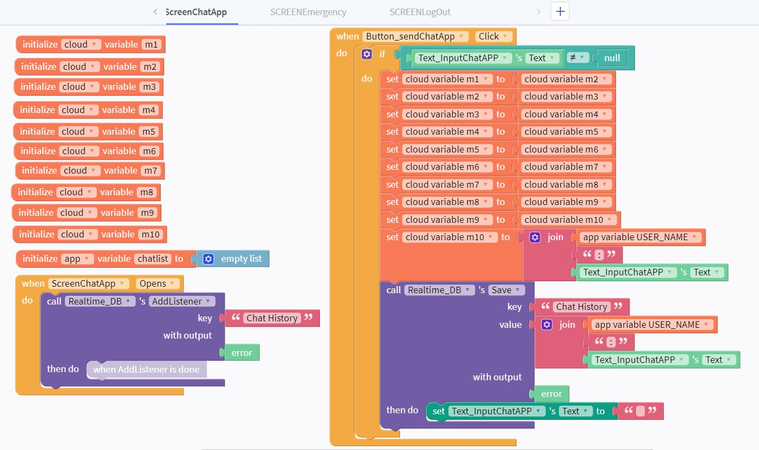

**3.4.6.a: Thunkable - Chat Feature of the family members**

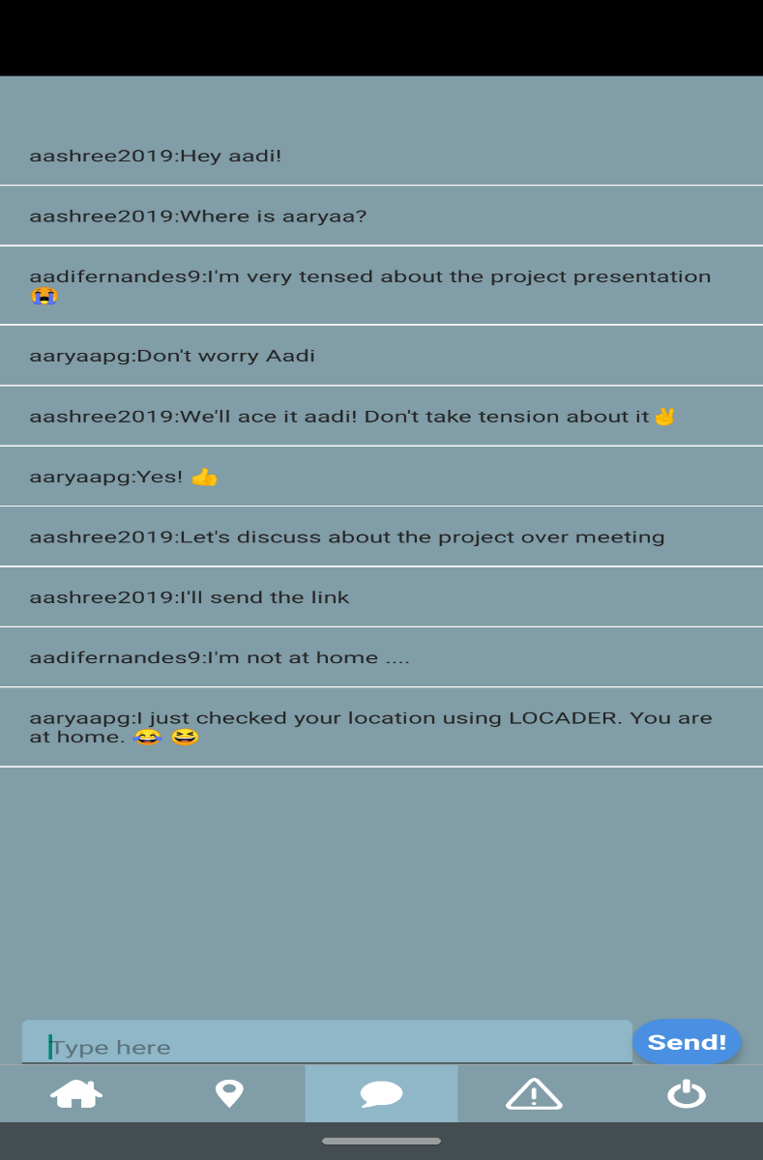

**3.4.6.b - Chat Feature on the Locader App**

The next functionality that we will be discussing about would be the chat feature of the app which uses the thunkable blocks alongside the firebase database to send and receive the messages. Basically, we would be using data fetched from the user details in order to set the names of the users in the chat. Then each user can go to the chat section and use the app to deliver messages to the family group. This could be used for basic communication purposes or for getting to know about the whereabouts of the members.

**3.4.7 SHOW LOCATION FEATURE:**

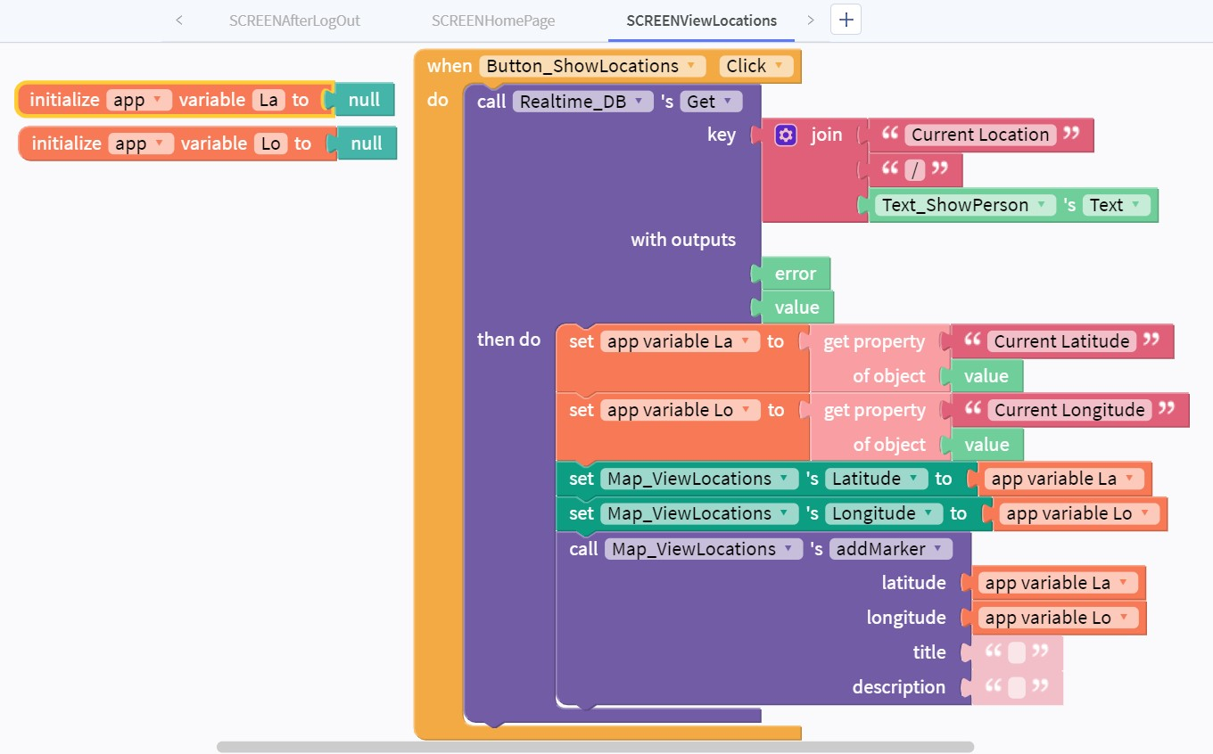

**3.4.7.a: Thunkable - Viewing Current Locations of the Users**

Now, coming to one of the final app features, we have one of the most important ones, which is used to view the current location of the users. Once we put the username of the user whose location we want to see, it will showcase us the exact location where the user is currently present through a marker. Hence, we would know where the family member is at any given point of time. The exact co-ordinates of the user are again obtained using the GPS and the latitude and longitude are basically retrieved from the firebase database.

They can be viewed using the map and the marker as shown in Fig 3.3.7.b, which showcases two test cases of the location. The marker with the blue spot is the current location of the user and the other marker is one of the stored locations the user is most likely to visit.

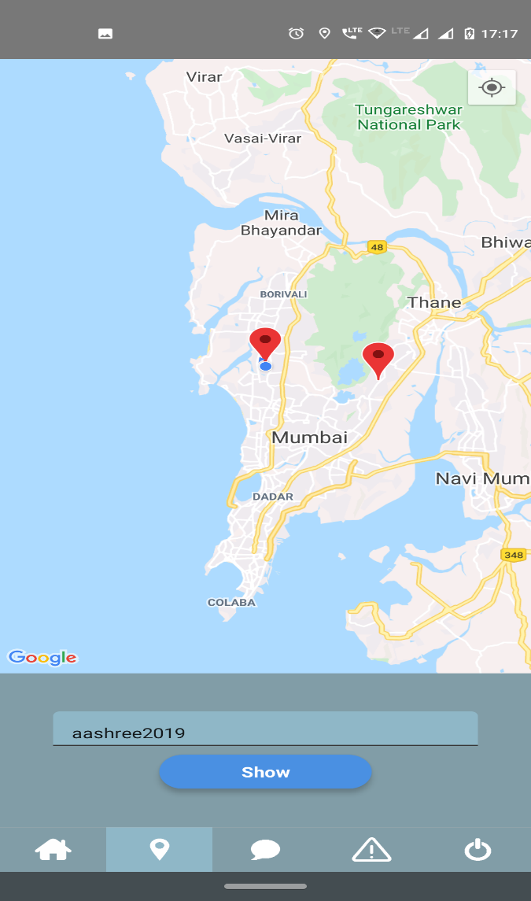

**3.4.7.b: Viewing the location of the users using Locader App**

**3.4.8 EMERGENCY FEATURE:**

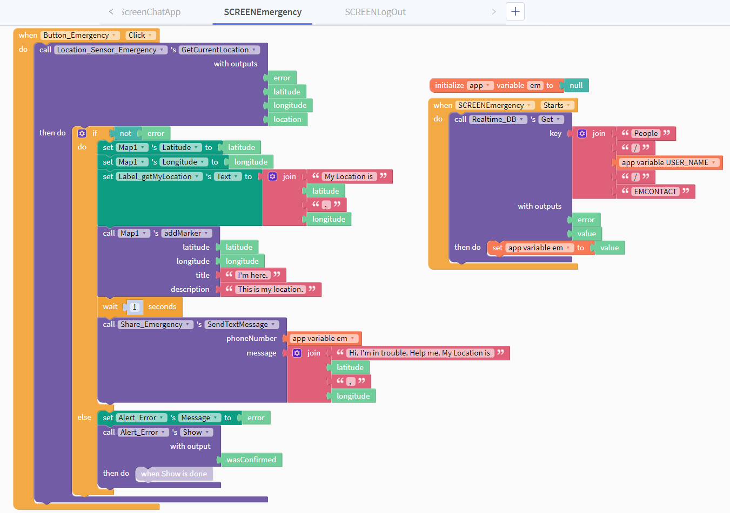

**3.4.8.a: Thunkable - Emergency Feature**

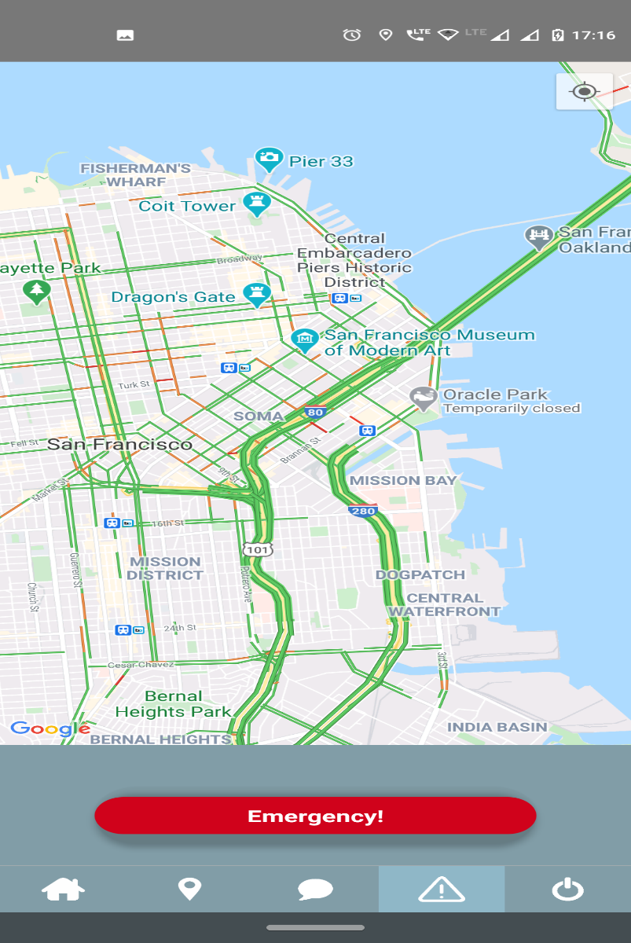

**3.4.8.b: Emergency Feature on Locader App**

The final functionality of the app is the emergency feature which can be pressed by the user in case there is any kind of danger that they are in and need some kind of assistance. This could be due to some accident or any other reason. Once the button is pressed, the data is retrieved from the firebase database and the message of the exact location of the user is sent to the registered family members which is recorded while signing up to the app. Once the message is received by the members – further action can be initiated, which could avert a major disaster or an unpleasant event.

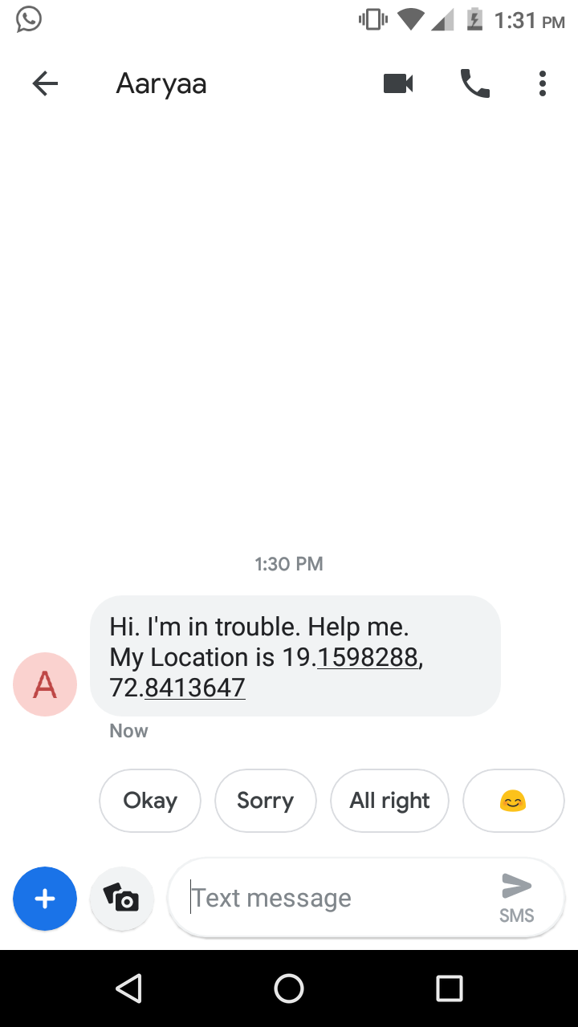

**3.4.8.c: Message and location sent to family members after the emergency button is triggered**

# CHAPTER 4

# RESULTS

**CHAPTER 4: RESULTS**

The desired output was achieved as observed in the completed hardware representation given below and the software as described above in detail. One of the ESP8266 is interfaced with the temperature and humidity sensor alongside the rain sensor (whose raining and not raining states are shown in Fig 4.1 and Fig 4.2 respectively). It is also coded to incorporate the current time, which is displayed on the LCD alongside these details.

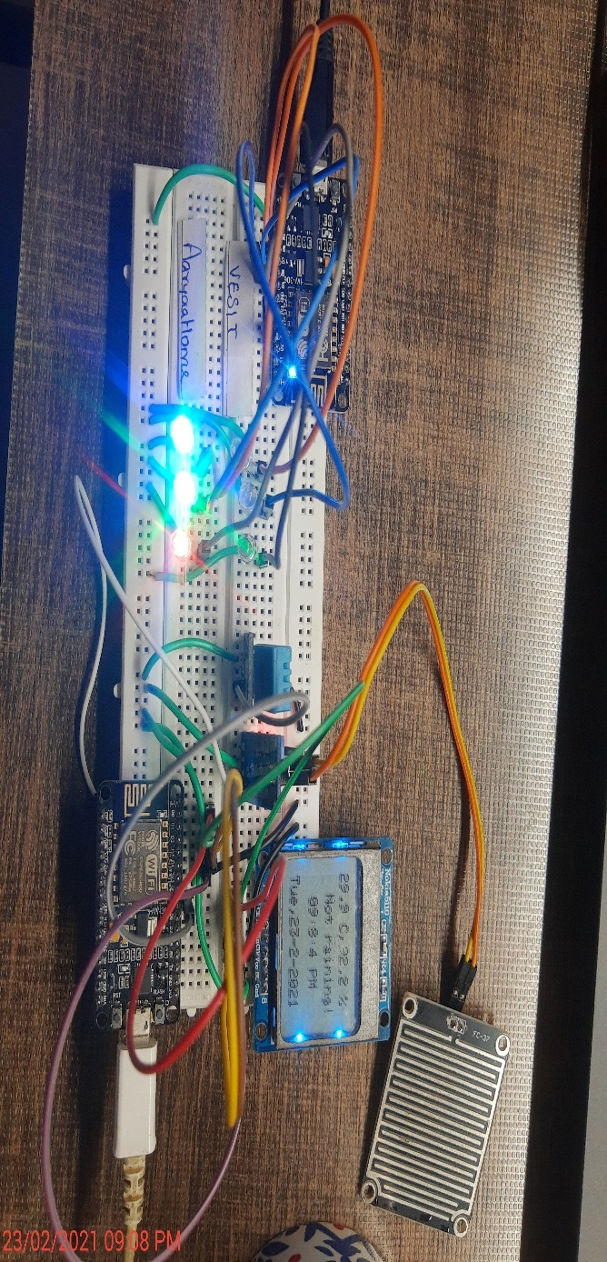

**4.1: Circuit when all users are at home and the rain sensor is deactivated**

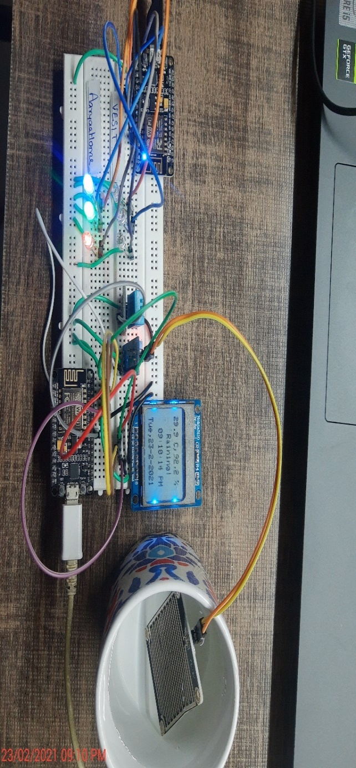

**4.2: Circuit when all users are at home and the rain sensor is activated**

The hardware functionalities work in tandem with the app and firebase database in order to provide an easy and visual representation of the locations of each and every user based on the locations recorded by the GPS. In Fig 4.3, we can see that all the three family members are at home because of which the NodeMCU has triggered every LED light to turn on at the location “Aarya’s Home”. Meanwhile, the LEDs at the position of VESIT remain dark since none of the users are present there. Moreover, in the Fig 4.5, we have the representation of the firebase database which tells us the accurate location of the users in terms of their respective latitudes and longitudes alongside the saved location where the users are most likely to be present, which in this case is our college, VESIT.

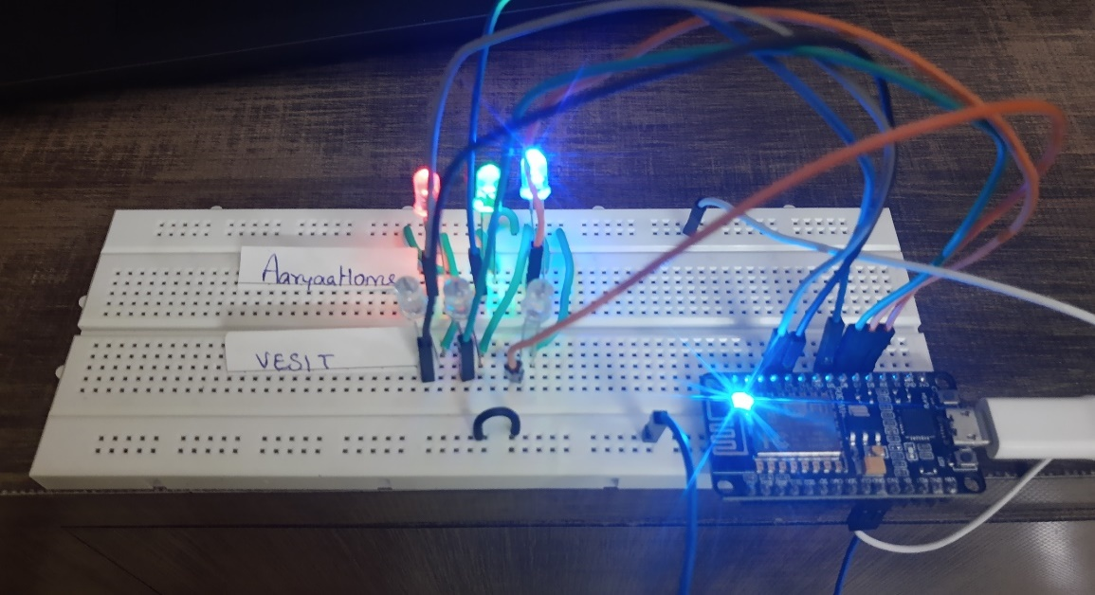

**4.3: All users are at home**

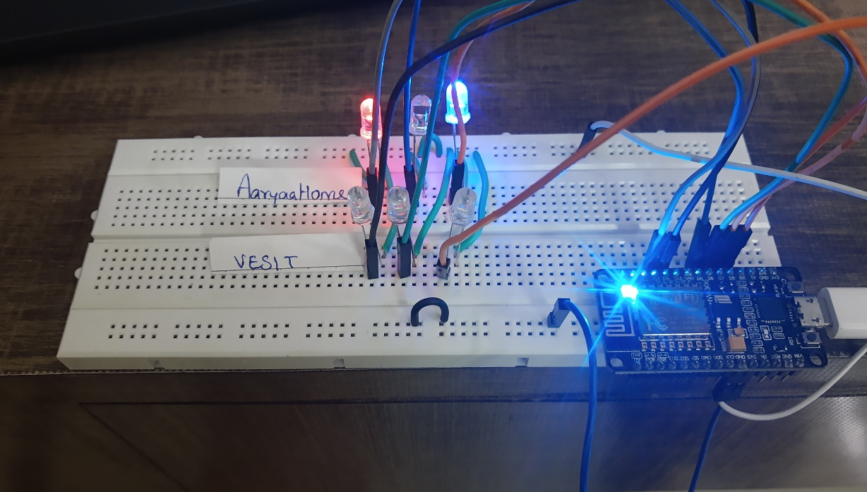

**4.4: All except one of the users (aashree2019) is not at home**

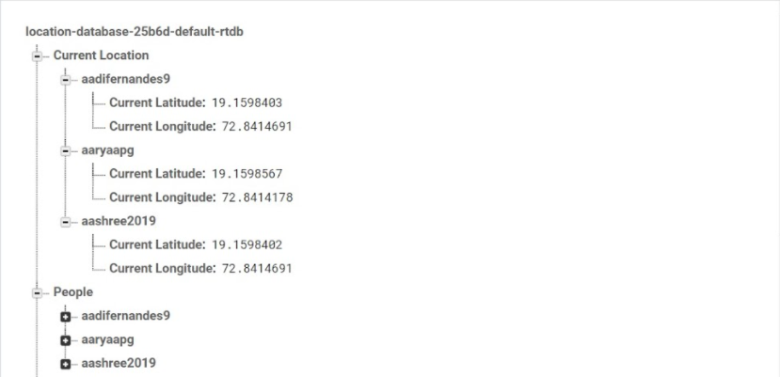

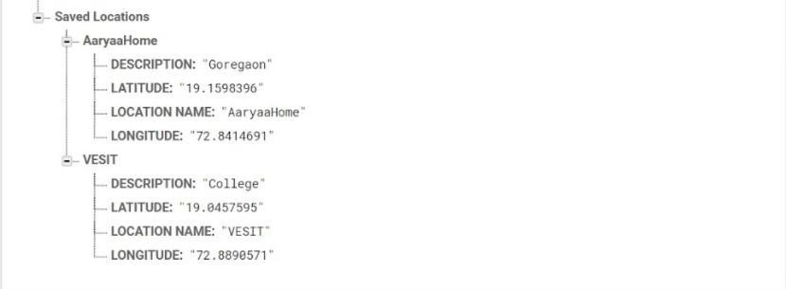

**4.5: Firebase: All the users are at home**

In Fig 4.4, we have made a change and the location of one of the users (aashree2019) was changed to a tertiary location because of which her LED at Home and VESIT is off, which means that the user is in transit. Once the user reaches VESIT, the respective LED would light up in order to indicate the completed transit and that the user has reached the location safely.

Likewise, in Fig 4.6, we have the firebase database showcasing the locations of the users. We can note that the locations of users “aadifernandes9” and “aaryaapg” are exactly the same while the location of the third user “aashree2019” is slightly different which means that the user has moved from their location and are currently in some other location. This is very sensitive to change which drastically improves the accuracy of the system with a minimal scope of error over the locations of the users.

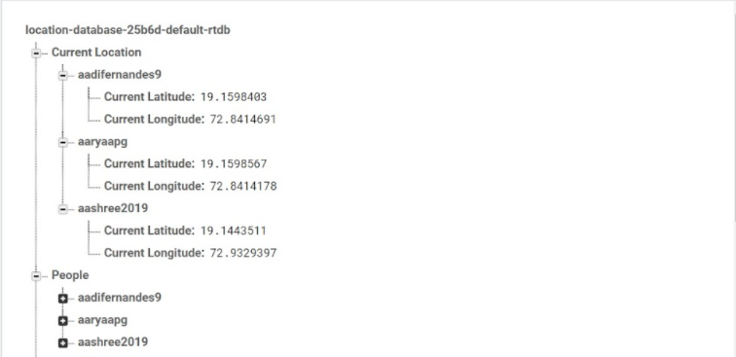

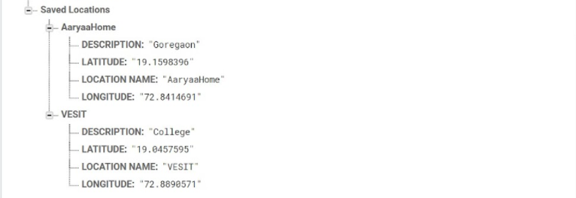

**4.6: Firebase: All except one of the users (aashree2019) is not at home**

The LEDs can be increased in number in order to showcase more users and locations in order to make this entire system more practical to use in real life applications. The ESP8266 can be reprogrammed in order to facilitate the deployment of multiple users at several different locations, or we could use other microcontrollers in order to scale this up to incorporate more users.

# CHAPTER 5

**FUTURE SCOPE AND ADVANTAGES**

**CHAPTER 5: ADVANTAGES, APPLICATIONS AND FUTURE SCOPE**

**5.1 ADVANTAGES:**

The curated system has several advantages that would make its adoption into our modern society seamless:

* Real time location tracking of family members and close friends
* Safety emergency system for contacting the near and dear ones and send them the location within a short time duration
* Security and Surveillance of the individuals using the application
* Hardware Implementation gives details about the location without needing the app which makes it more user friendly, especially for someone who is not in terms with our new world technologies. So, you don’t need to necessarily have the software in order to know the locations.
* The User Interface is very seamless and can be used easily by anyone
* Login and Signup for users ensures the security and prevents any kind of unauthorized access to the locations of the family members
* Chat feature to keep an update of the whereabouts of users
* The rain sensor can detect the change in climate and alert the user in case it’s raining around their locality
* The Thunkable interface drastically improves the User Experience as it is much more intuitive to tweak and remodel based on the changing requirements
* Using readily available and widely used APIs makes the system more accurate

**5.2 APPLICATIONS:**

1. Can be used for safety and security of loved ones
2. Could be used to call upon emergency services in dire circumstances
3. Can be used to keep in touch with family members about their location
4. Could determine location of the person easily and accurately without need for operation any device manually as the LED shows the location
5. To know if the user is in any kind of emergency and to be equipped to send help at the earliest possible juncture to avoid any mishap

**5.3 FUTURE SCOPE:**

This pilot project has huge scope of improvements that could be done in order to make it even more efficient. The number of sensors can surely be increased in order to accommodate more functions within the same module. The entire system can be scaled up using either multiple ESP8266 or other controllers like Raspberry Pi 3, which would have more ports to be able to facilitate a greater number of available pins. This can lead to an increase in the number of users that can use the hardware LEDs for representing their locations. That being said, we can also have more locations in the system, for which the controller needs slight modifications in the program. The application can be migrated from the Thunkable framework to a hard coded interface such as android studio in order to further improve the user interface and experience alongside opening the realm for further improvement through other APIs and applications that would be available.

The app can also be further enhanced to have multiple features such as accident detection and automatic dispatch of emergency services in case that happens. Voice recognition could be incorporated in the app for seamless operations as well as an addition security layer apart from the UserID and password. We could also add a synchronized reminder or group alarm that would notify all the family members of a particular event or task that needs to be performed. This could also be coupled with the exact google maps functionality in order to be able to tell us the locations of the nearby amenities, which would be of major assistance in order to not only retrieve the exact location, but also know the landmarks around it, or for using it casually to search for places to visit.

Another advance and yet a highly intuitive feature could be the use of Machine Learning in order to predict the most probable location that a person could be at. The logic behind it is that in case there is some emergency or the phone is out of service or network area, there is a higher chance of being able to locate the person based on the locations that they usually visit. The accuracy of this may differ but the probability of being able to locate them would increase significantly. Moreover, the longer the duration it is recorded, the more data will be collected and fed which would eventually lead to a much more accurate predictive system.

These are some improvements that could make the system much more reliable with more diverse applications under any real-world scenario.

**CHAPTER 6**

**CONCLUSIONS**

**CHAPTER 6: CONCLUSION:**

This Real-Time location clock works by utilizing a NodeMCU, which is connected to a real-time database on Google Firebase. The user’s phone (running our *Locader* app) is used to update the user’s location on Firebase. This then triggers the Microcontroller to light up the user’s respective LED on the clock interface, effectively providing the location of the member among the predetermined destinations that they are most likely to be in. If the user is in transit, then that LED will glow and the exact location of the user would be provided as an SMS trigger to the user through the Locader app.

The following aspects have been covered within this comprehensive project that we have undertaken:  
**Hardware**:

* Contains an LCD that shows the Date, Time and Day - Using Network Time Protocol
* Localized Real Time Weather Report - Temperature, Humidity, Rain Detection

**Software**:

* Login and Sign-up page of the App
* Email Authentication
* Entering Details of users
* Connection with Firebase Realtime Database

This project is an effective application that can be used as an emergency messaging location detection as well as messaging system. It will help in security and surveillance as well as Real time tracking. The weather report adds an additional layer of its functionality which furthermore leads to a comprehensive system that could be deployed for its plethora of features. The future scope and real-world implementation of this project can be done by adding features such as location prediction, in case the availability of network is an issue. The location of family members and loved ones can be known instantly and can be used to ensure their safety during travelling.

**CHAPTER 7**

**REFERENCES**

**CHAPTER 7: REFERENCES**

[1] Guzman, Jethro B. de, Ritz Carlo C. de Guzman and R. Ado. “Mobile Emergency Response Application Using Geolocation for Command Centers.” *International Journal of Computer and Communication Engineering* 3 (2014): 235-238.

[2] Liao, Lin, Dieter Fox, and Henry Kautz. “Extracting Places and Activities from GPS Traces Using Hierarchical Conditional Random Fields.” The International Journal of Robotics Research 26, no. 1 (January 2007): 119–34.

[3] Daniel Ashbrook and Thad Starner. 2003. Using GPS to learn significant locations and predict movement across multiple users. Personal Ubiquitous Computing 7, 5 (October 2003), 275–286.

[4] https://docs.thunkable.com/

[5] Khan, Arsalan & Bibi, Farzana & Dilshad, Muhammad & Ahmed, Salman & Ktk, Zia & Ali, Haider. (2018). Accident Detection and Smart Rescue System using Android Smartphone with Real-Time Location Tracking. International Journal of Advanced Computer Science and Applications. 9. 10.14569/IJACSA.2018.090648.

[6] Braaten, N. and Clock), W., 2020. Weasley Clock (Magical Location Clock). Available at: <https://www.hackster.io/user68416/weasley-clock-magical-location-clock-819125>

[7] E. D. Kaplan and C. J. Hegarty. Understanding GPS: Principles and Applications. Artech House, second edition, 2005

[8] Jie Liu, Bodhi Priyantha, Ted Hart, Heitor S. Ramos, Antonio A. F. Loureiro, and Qiang Wang. Energy efficient GPS sensing with cloud offloading. In Proceedings of SenSys’12

# CHAPTER 8

# APPENDIX

**1. NodeMCU (ESP8266) 1 SETUP FOR FIREBASE, WIFI CONNECTIVITY AND LOCATIONS**

/*__________Libraries__________*/

//For Firebase & WiFi Connectivity

#include <ESP8266WiFi.h>

#include <FirebaseESP8266.h>

#include <FirebaseESP8266HTTPClient.h>

#include <FirebaseFS.h>

#include <FirebaseJson.h>

#include <deprecated.h>

//For Firebase & WiFi Connectivity

#define FIREBASE_HOST "*********"

#define FIREBASE_AUTH "*********"

#define WIFI_SSID "*********"

#define WIFI_PASSWORD "*********"

#define AXpin D3//Red

#define AYpin D4//Red

#define BXpin D5//Green

#define BYpin D6//Green

#define CXpin D7//Blue

#define CYpin D8//Blue

FirebaseData firebaseData;

FirebaseJson json;

double A_lat, A_long, B_lat, B_long, C_lat, C_long; //Users, ie, Current Location

String x_lat, x_long, y_lat, y_long; //Saved Locations in String

double X_lat, X_long, Y_lat, Y_long; //Saved Locations in String

int AX, AY, AT, BX, BY, BT, CX, CY, CT;

/*__________Setup__________*/

void setup() {

Serial.begin(9600);

//Connecting to WiFi

WiFi.begin(WIFI_SSID, WIFI_PASSWORD);

Serial.print("connecting");

while (WiFi.status() != WL_CONNECTED) {

Serial.print(".");

delay(500);

}

Serial.println();

Serial.print("Connected: ");

Serial.println(WiFi.localIP());

Firebase.begin(FIREBASE_HOST, FIREBASE_AUTH);

Firebase.reconnectWiFi(true);

pinMode(AXpin, OUTPUT);

pinMode(AYpin, OUTPUT);

pinMode(BXpin, OUTPUT);

pinMode(BYpin, OUTPUT);

pinMode(CXpin, OUTPUT);

pinMode(CYpin, OUTPUT);

}

/*__________Loop__________*/

void loop() {

getCurrentLocations();

getSavedLocations();

compareCurrentSaved();

glowLED();

}

/*__________Functions__________*/

void getCurrentLocations(){

//aaryaapg Latitude

if(Firebase.getDouble(firebaseData, "/Current Location/aaryaapg/Current Latitude")) {

if (firebaseData.dataType() == "double") {

A_lat = firebaseData.doubleData();

//Serial.println(A_lat,7);

}

}

else {

Serial.println(firebaseData.errorReason());

}

//aaryaapg Longitude

if(Firebase.getDouble(firebaseData, "/Current Location/aaryaapg/Current Longitude")) {

if (firebaseData.dataType() == "double") {

A_long = firebaseData.doubleData();

//Serial.println(A_long,7);

}

}

else {

Serial.println(firebaseData.errorReason());

}

//aashree2019 Latitude

if(Firebase.getDouble(firebaseData, "/Current Location/aashree2019/Current Latitude")) {

if (firebaseData.dataType() == "double") {

B_lat = firebaseData.doubleData();

//Serial.println(B_lat,7);

}

}

else {

Serial.println(firebaseData.errorReason());

}

//aashree2019 Longitude

if(Firebase.getDouble(firebaseData, "/Current Location/aashree2019/Current Longitude")) {

if (firebaseData.dataType() == "double") {

B_long = firebaseData.doubleData();

//Serial.println(B_long,7);

}

}

else {

Serial.println(firebaseData.errorReason());

}

//aadifernandes9 Latitude

if(Firebase.getDouble(firebaseData, "/Current Location/aadifernandes9/Current Latitude")) {

if (firebaseData.dataType() == "double") {

C_lat = firebaseData.doubleData();

//Serial.println(B_lat,7);

}

}

else {

Serial.println(firebaseData.errorReason());

}

//aadifernandes9 Longitude

if(Firebase.getDouble(firebaseData, "/Current Location/aadifernandes9/Current Longitude")) {

if (firebaseData.dataType() == "double") {

C_long = firebaseData.doubleData();

//Serial.println(B_long,7);

}

}

else {

Serial.println(firebaseData.errorReason());

}

}

void getSavedLocations() {

//AaryaaHome Latitude

if(Firebase.getString(firebaseData, "/Saved Locations/AaryaaHome/LATITUDE")) {

if (firebaseData.dataType() == "string") {

x_lat = firebaseData.stringData();

X_lat = x_lat.toDouble();

//Serial.println(X_lat,7);

}

}

else {

Serial.println(firebaseData.errorReason());

}

//AaryaaHome Longitude

if(Firebase.getString(firebaseData, "/Saved Locations/AaryaaHome/LONGITUDE")) {

if (firebaseData.dataType() == "string") {

x_long = firebaseData.stringData();

X_long = x_long.toDouble();

//Serial.println(X_long,7);

}

}

else {

Serial.println(firebaseData.errorReason());

}

//VESIT Latitude

if(Firebase.getString(firebaseData, "/Saved Locations/VESIT/LATITUDE")) {

if (firebaseData.dataType() == "string") {

y_lat = firebaseData.stringData();

Y_lat = y_lat.toDouble();

//Serial.println(Y_lat,7);

}

}

else {

Serial.println(firebaseData.errorReason());

}

//VESIT Longitude

if(Firebase.getString(firebaseData, "/Saved Locations/VESIT/LONGITUDE")) {

if (firebaseData.dataType() == "string") {

y_long = firebaseData.stringData();

Y_long = y_long.toDouble();

//Serial.println(Y_long,7);

}

}

else {

Serial.println(firebaseData.errorReason());

}

}

**2. LED INTERFACING**

void compareCurrentSaved() {

//Compare A

if(int(A_lat*10000) == int(X_lat*10000)){

if(int(A_long*10000) == int(X_long*10000)){

Serial.println("aaryaapg is at AaryaaHome");

AX = 1;

AY = 0;

AT = 0;

}

}

else if(int(A_lat*10000) == int(Y_lat*10000)){

if(int(A_long*10000) == int(Y_long*10000)){

Serial.println("aaryaapg is at VESIT");

AY = 1;

AX = 0;

AT = 0;

}

}

else {

Serial.println("aaryaapg is travelling");

AT = 1;

AX = 0;

AY = 0;

}

//Compare B

if(int(B_lat*10000) == int(X_lat*10000)){

if(int(B_long*10000) == int(X_long*10000)){

Serial.println("aashree2019 is at AaryaaHome");

BX = 1;

BY = 0;

BT = 0;

}

}

else if(int(B_lat*10000) == int(Y_lat*10000)){

if(int(B_long*10000) == int(Y_long*10000)){

Serial.println("aashree2019 is at VESIT");

BY = 1;

BX = 0;

BT = 0;

}

}

else {

Serial.println("aashree2019 is travelling");

BT = 1;

BX = 0;

BY = 0;

}

//Compare C

if(int(C_lat*10000) == int(X_lat*10000)){

if(int(C_long*10000) == int(X_long*10000)){

Serial.println("aadifernandes9 is at AaryaaHome");

CX = 1;

CY = 0;

CT = 0;

}

}

else if(int(C_lat*10000) == int(Y_lat*10000)){

if(int(C_long*10000) == int(Y_long*10000)){

Serial.println("aadifernandes9 is at VESIT");

CY = 1;

CX = 0;

CT = 0;

}

}

else {

Serial.println("aadifernandes9 is travelling");

CT = 1;

CX = 0;

CY = 0;

}

}

void glowLED() {

//For User A (aaryaapg)

if(AX){

digitalWrite(AXpin, HIGH);

digitalWrite(AYpin, LOW);

}

else if(AY){

digitalWrite(AXpin, LOW);

digitalWrite(AYpin, HIGH);

}

else{ //Travelling

digitalWrite(AXpin, LOW);

digitalWrite(AYpin, LOW);

}

//For User B (aashree2019)

if(BX){

digitalWrite(BXpin, HIGH);

digitalWrite(BYpin, LOW);

}

else if(BY){

digitalWrite(BXpin, LOW);

digitalWrite(BYpin, HIGH);

}

else{ //Travelling

digitalWrite(BXpin, LOW);

digitalWrite(BYpin, LOW);

}

//For User C (aadifernandes9)

if(CX){

digitalWrite(CXpin, HIGH);

digitalWrite(CYpin, LOW);

}

else if(CY){

digitalWrite(CXpin, LOW);

digitalWrite(CYpin, HIGH);

}

else{ //Travelling

digitalWrite(CXpin, LOW);

digitalWrite(CYpin, LOW);

}

}

//https://github.com/mobizt/Firebase-ESP8266/blob/master/README.md

//http://www.lib4dev.in/info/mobizt/Firebase-ESP32/144101498

**3. NodeMCU (ESP8266) 2 SETUP**

/*__________Libraries__________*/

#include <Adafruit_PCD8544.h> //Library for Nokia 5110 LCD

#include <Adafruit_GFX.h> //Adafruit Graphics Library

#include <gfxfont.h>

#include <SPI.h> //For communication between NodeMCU and LCD

#include <DHT.h> // DHT11 temperature and humidity sensor Library

#include <Time.h>

#include <TimeLib.h>

#include <NTPClient.h> //Library for NTP Protocolj

#include <ESP8266WiFi.h>

#include <WiFiUdp.h>

#define DHTPIN D5 // DHTPIN : We connected DHT11 Sensor to pin D5 (ie, GPIO0 of ESP8266)

#define DHTTYPE DHT11 // We used DHT11. (Can use DHT22 or any other from this series)

#define RAINPIN A0 // FC-37 Analog Output pin is connected to A0

Adafruit_PCD8544 display = Adafruit_PCD8544(D4, D3, D2, D1, D0); // Nokia 5110 LCD module connections (CLK, DIN, D/C, CS, RST)

DHT dht = DHT(DHTPIN, DHTTYPE); // DHT dht = DHT(DHTPIN,Sensor_type), "dht" is the name of the sensor (variable)

const char *ssid = "*********";

const char *password = "*********";

int DAY, MONTH, YEAR, SECONDS, HOURS ,MINUTES, WEEKDAY;

long int time_now; //Epoch Time

WiFiUDP ntpUDP;

NTPClient timeClient(ntpUDP);

void setup() {

Serial.begin(9600); //Begin serial communication at a baud rate of 9600

pinMode(RAINPIN, INPUT);

dht.begin(); //Initialize the sensor

WiFi.begin(ssid, password);

display.begin(); //Initialize the display

display.clearDisplay();

display.setContrast(50); // Adjust for your display

display.setTextColor(BLACK, WHITE);

display.display();

while ( WiFi.status() != WL_CONNECTED ) {

delay ( 500 );

Serial.print ( "." );

}

timeClient.begin();

}

**4. TEMPERATUE AND HUMIDITY SENSOR (DHT11) INTERFACING**

void loop() {

int h = dht.readHumidity();

int tc = dht.readTemperature();

float tf = dht.readTemperature(true); // Get Temperature in F

float hif = dht.computeHeatIndex(tf, h); // Heat index in F, Default

float hic = dht.computeHeatIndex(tc, h, false); // Heat index in C

// This is just for the serial Monitor

Serial.print("Humidity = ");

Serial.print(h);

Serial.print("% |");

Serial.print("Temperature = ");

Serial.print(tc);

Serial.print("\xC2\xB0 C ie, "); // Serial.print(" \xC2\xB0"); is used to print the degree symbol in the serial monitor

Serial.print(tf);

Serial.print("\xC2\xB0 F |");

Serial.print("Heat index = ");

Serial.print(hic);

Serial.print("\xC2\xB0 C ie, ");

Serial.print(hif);

Serial.println("\xC2\xB0 F |");

// To print Temperature (in Celcius)on LCD

display.setCursor(0, 0); //(18,12); (35,0)

display.printf("%02u.%1u C", (tc)%100, (tc)%10); // print degree symbol ( C ): %02u.%1u C

display.setCursor(35, 0);

display.printf(",");

// To print humidity (in %) on LCD

display.setCursor(43, 0); //(24, 40); (40, 10)

display.printf("%02u.%1u %%", (h)%100, (h)%10); // print degree symbol ( % ): %02u.%1u %%

display.display(); // To update the display

5. RAIN SENSOR (FC-37) INTERFACING

//To print whether it is raining or not

int raining = analogRead(RAINPIN);

if(raining < 800){

Serial.println(raining); //Serial Monitor

display.setCursor(20,12);

display.printf("Raining!"); //LCD

display.display();

}

else {

Serial.println(raining); //Serial Monitor

display.setCursor(12,12);

display.printf("Not raining!"); //LCD

display.display();

}

**6. NETWORK TIME PROTOCOL (NTP) CONFIGURATION**

//Using the NTP Protocol

timeClient.update();

time_now = timeClient.getEpochTime() + (19800); //5 hours 30 minutes = 19800s (India is GMT+5:30)

DAY = day(time_now);

MONTH = month(time_now);

YEAR = year(time_now);

HOURS = hourFormat12(time_now);

MINUTES = minute(time_now);

SECONDS = second(time_now);

WEEKDAY = weekday(time_now);

LCD_DISPLAY(String(DAY), String(MONTH), String(YEAR));

delay(1000);

}

**7. LCD INTERFACING**

void LCD_DISPLAY(String DAY, String MONTH, String YEAR)

{

display.clearDisplay();

display.setTextSize(1);

display.setTextColor(BLACK);

display.setCursor(13,25); //(0,5)

if (HOURS > 9){

if(isPM(time_now))

display.println(String(HOURS) + ":" + String(MINUTES) + ":" + String(SECONDS) + " " + "PM");

else

display.println(String(HOURS) + ":" + String(MINUTES) + ":" + String(SECONDS) + " " + "AM");

}

else if (HOURS < 10){

if(isPM(time_now))

display.println("0" + String(HOURS) + ":" + String(MINUTES) + ":" + String(SECONDS) + " " + "PM");

else

display.println("0" + String(HOURS) + ":" + String(MINUTES) + ":" + String(SECONDS) + " " + "AM");

}

display.setCursor(0, 40);

//Printing the weekday

switch(WEEKDAY)

{

case 1: display.println("Sun,"); break;

case 2: display.println("Mon,"); break;

case 3: display.println("Tue,"); break;

case 4: display.println("Wed,"); break;

case 5: display.println("Thu,"); break;

case 6: display.println("Fri,"); break;

default: display.println("Sat,");

}

display.setCursor(24, 40);

display.println(DAY + "-" + MONTH + "-" + YEAR);

}

**CHAPTER 9**

# DATASHEETS

**9.1. NodeMCU (ESP8266) Datasheet:**

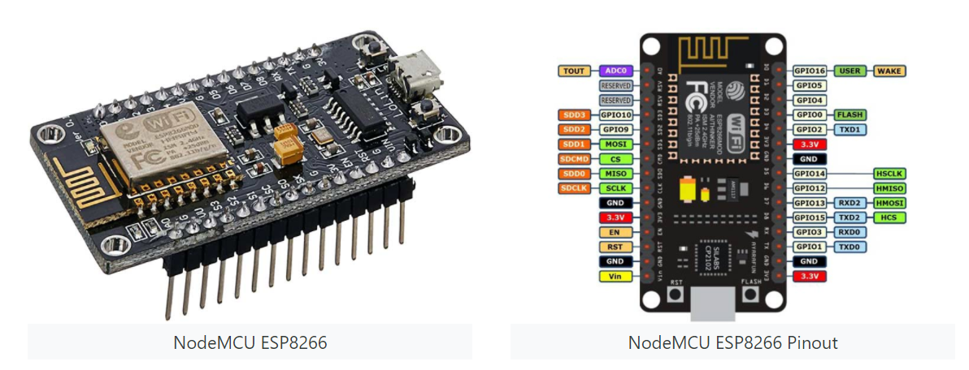

FEATURES

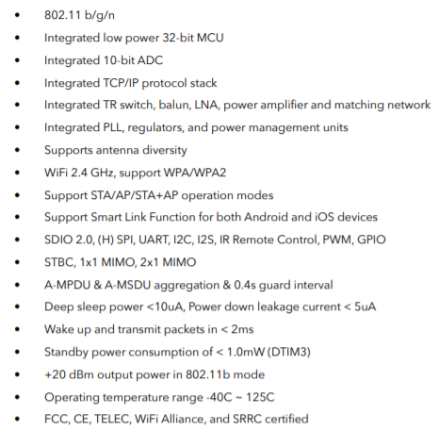

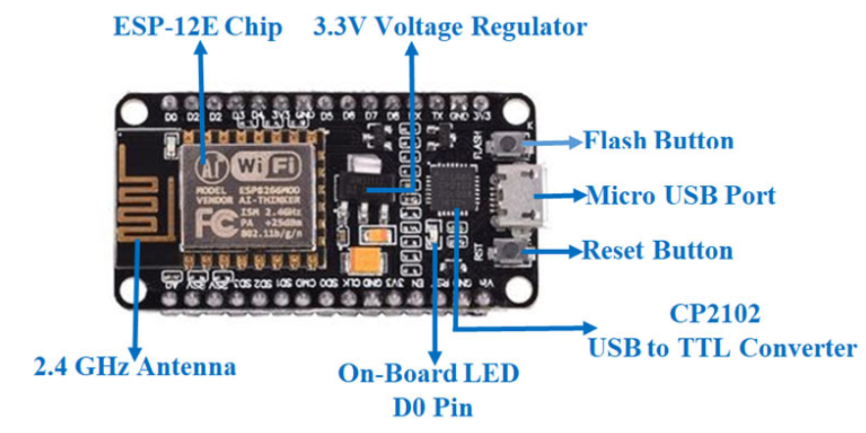

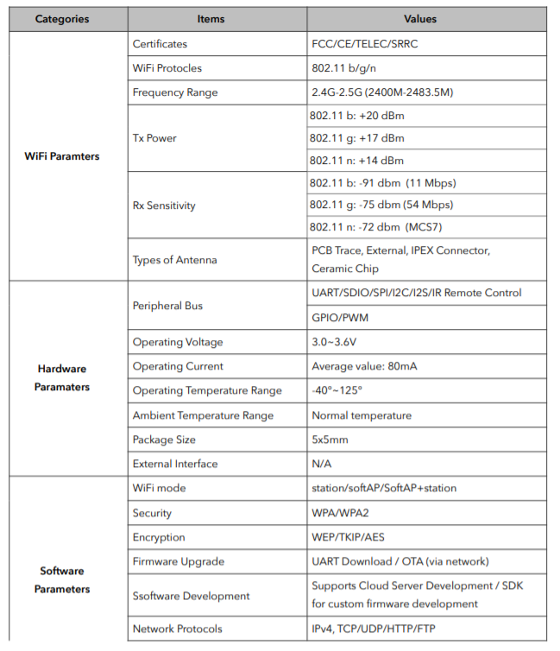



**9.2. LEDs Datasheet:**

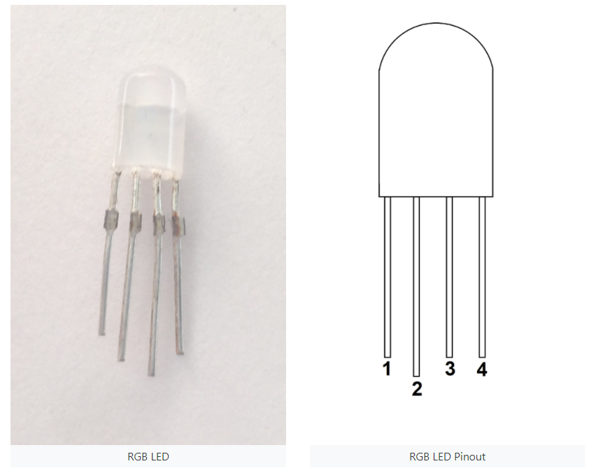

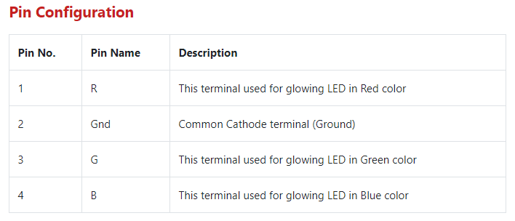

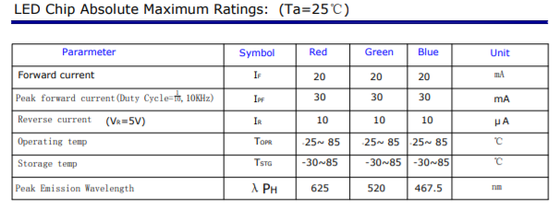

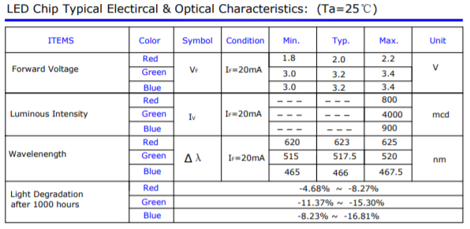

**9.3. DHT11 Temperature & Humidity Sensor Module Datasheet**

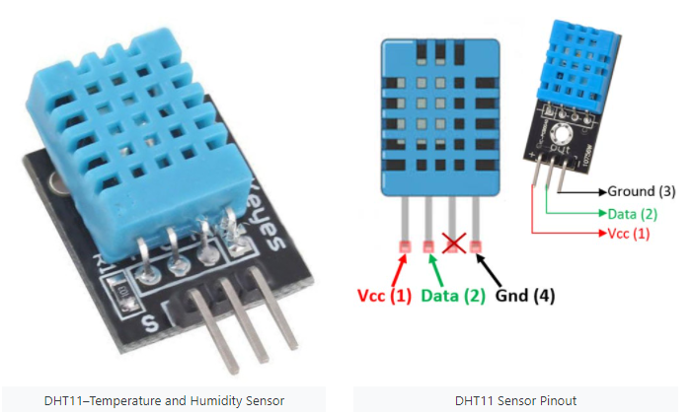

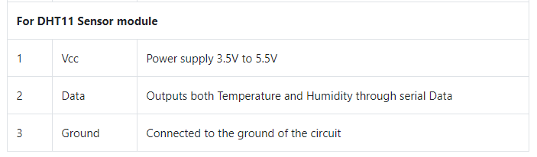

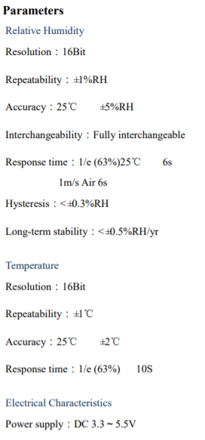

**9.4. FC-37 Rain Sensor Module Datasheet:**

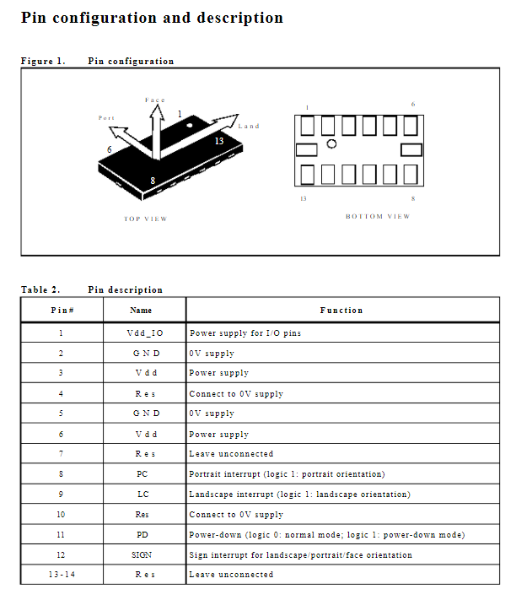

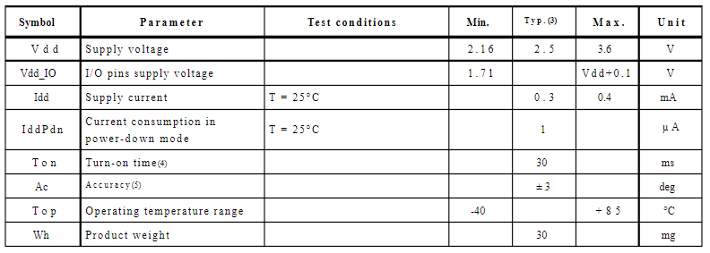

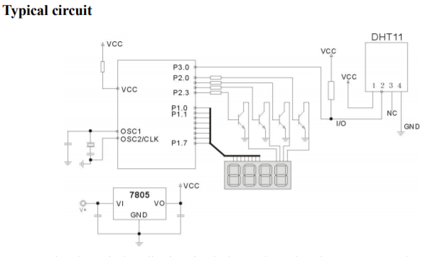

**9.5. Nokia 5110 LCD datasheet:**

